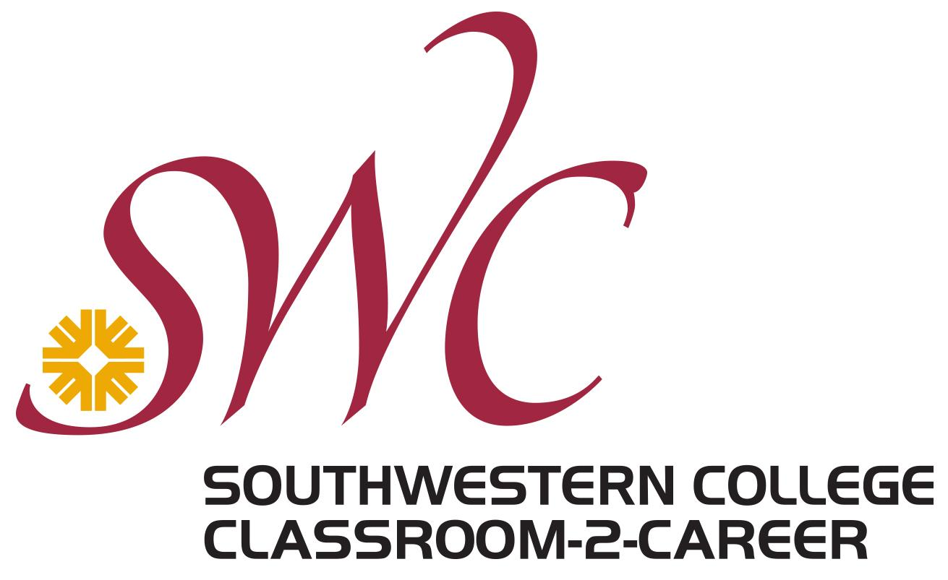 Are our students prepared for a career?

“While career services and advising are provided to students who seek them out, studies suggest that those who need such services the most are the least likely to take advantage of them.”
—Davis Jenkins, Community College Research Center

Career readiness is no longer the job of just career services professionals…. It’s all of ours. CAREER PATHWAYS

At a national level, it is estimated that Career Services has only been able to serve 10-11% of a student population

At SWC, 67% of our students have some sort of Financial Aid, which means that most of our students
- work (sometimes multiple) jobs
- have families to support
- facing food or home insecurities
all on top of balancing their school work, making an additional appointment to meet with a career counselor or attend a workshop a luxury our students can’t afford.

Identified gaps in recent graduates’ preparedness
In a 2018 survey conducted by the Association of American Colleges & Universities regarding education and the Future of Work, employers ranked these 15 skills as being as the most important for an employee to have to be successful
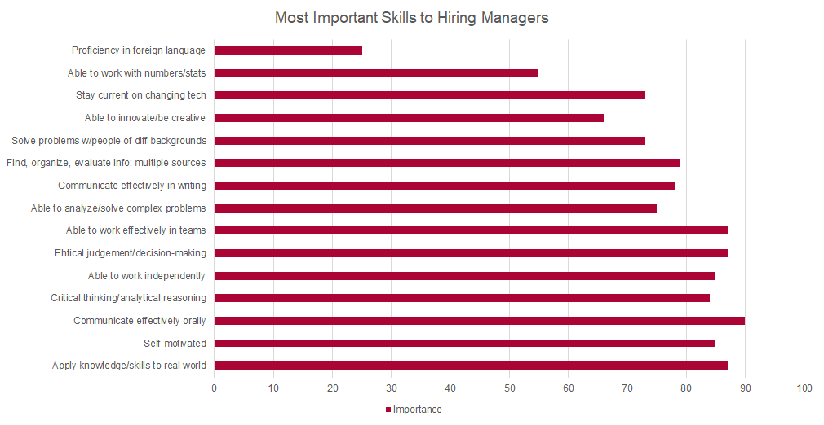

The Association of American Colleges & Universities took this research a step further and asked employers to rate how recent grads performed in these skills. As you can see by the yellow bars that have been added to this chart, recent graduates aren’t demonstrating these abilities well in their workplaces.

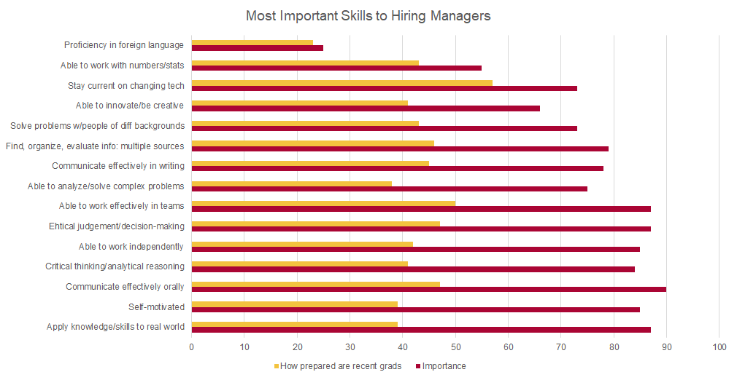

At first glance, this data set is rather alarming. The opportunity we have in helping them perform better, is to help them connect their academic learning and these important skills with what’s happening in real world work environments.

Career Training Resources:

Southwestern Career Center: | Provides a host of career related information directed towards serving students and the South Bay. From career interest inventories, to career related workshops, to providing steps to career success, to exploring different majors/careers to matching students with current internship opportunities and much more!
San Diego WorkForce Partnership | Provides San Diego-specific job opportunities, and links job seekers with employers. Emphasis on diversity.
State of California EDD | State Department of Labor website that links job seekers with job training and job opportunities. Some of the job training is free or low cost.
San Diego Continuing Education Career Training | Resource through the San Diego Community College system that links job seekers with free job training opportunities in various fields.
Second Chance Program Job Readiness Training | Specifically for people who have been incarcerated. Links them with job training and opportunities.
San Diego County Job training and Education | County links for job training and education for people of all ages.
Career One Stop | Funded by the US Department of Labor. Links to job training and job opportunities nationwide.

