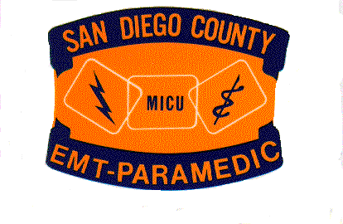
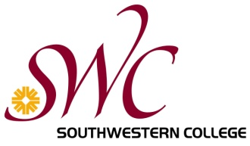

Established 1988

New Class Added!!!

Due to community demand and at the request of both the County of San Diego EMS Office and several of the large providers in town, Southwestern College will be adding a second paramedic cohort beginning this spring.

- Applications for our next paramedic class will be accepted beginning October 20th, 2015. You may download the application and many of your questions can answered by following this link https://www.swccd.edu/index.aspx?page=1023
- This will be an accellerated class. During the Spring class will be in session on Tuesday/Thursday/Saturday, but during the summer classes will alternate between 4 days & 5 days each week. Start to finish the class will be approximately 11 months.
- The estimated costs for tuition, books and supplies is approximately $3750. There are a number of grants, waivers, free money & student loans available through the college and the State to which most folks have access.
- Enrollment will be limited and applicants must meet the college’s minimum requirements for entry into the program. These prerequisites can be found at the link above.
- The tentative schedule is:

- Paramedic Prep for those who need it will be run on an accellerated format from January 11-21st, 2016.
- First day of paramedic class will be January 22nd, 2016, and didactic will run through August 12, 2016.
- Clinical rotations will begin on August 16 and be complete approximately 1 month later
- Field internships are scheduled to begin at the conclusion of each student’s clinical rotation
- Tentative graduation on January 14th, 2017!

If you have questions please visit our website. You may also contact Karen Cook at 619-216-6760.

