Student Online Procedures

After logging into Canvas via MySWC, students need to self-enroll in the LAS Online Tutoring Center Canvas course using the self-enrollment link:

https://swccd.instructure.com/enroll/NKP9TP

After you enroll, here’s what you need to do:

1) Login to the LAS Online Tutoring Center Canvas course
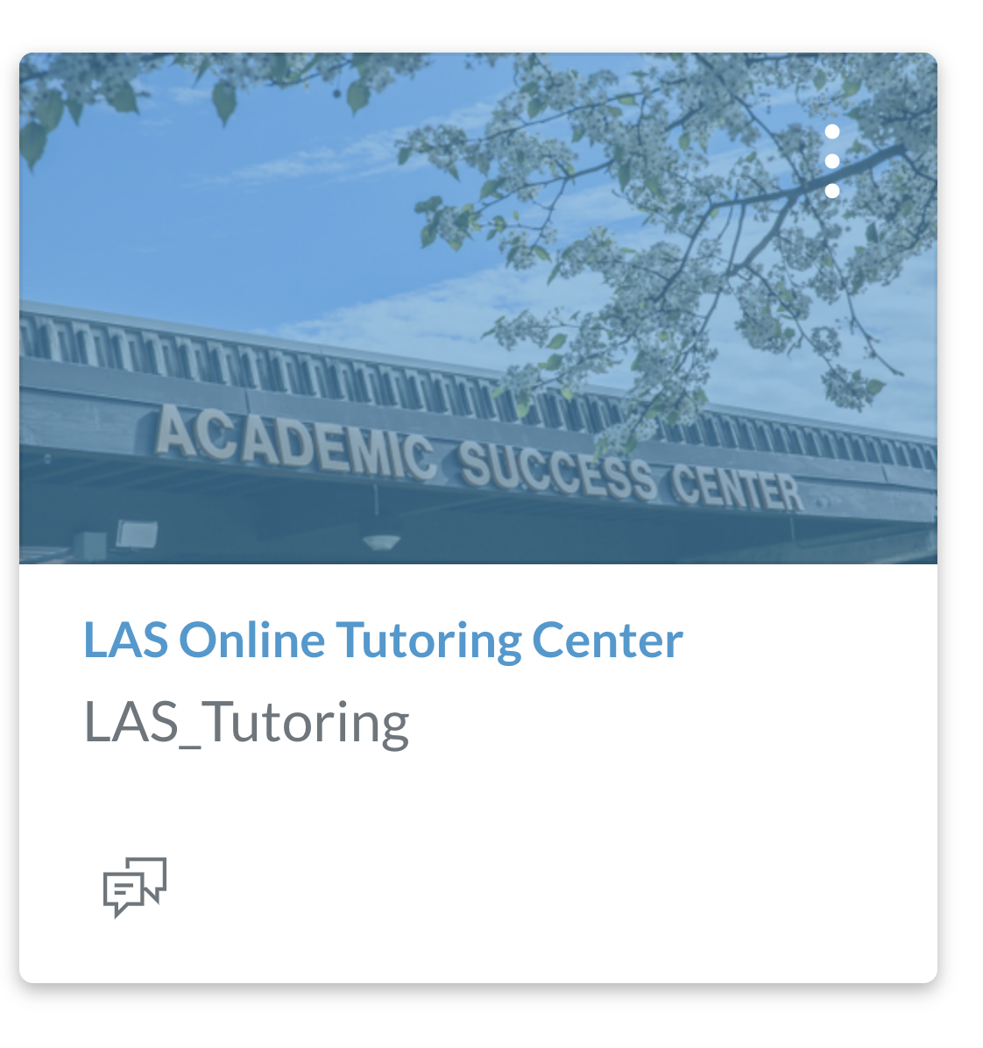

2) Click on the “Cross Discipline Tutoring” button at the bottom of the home page
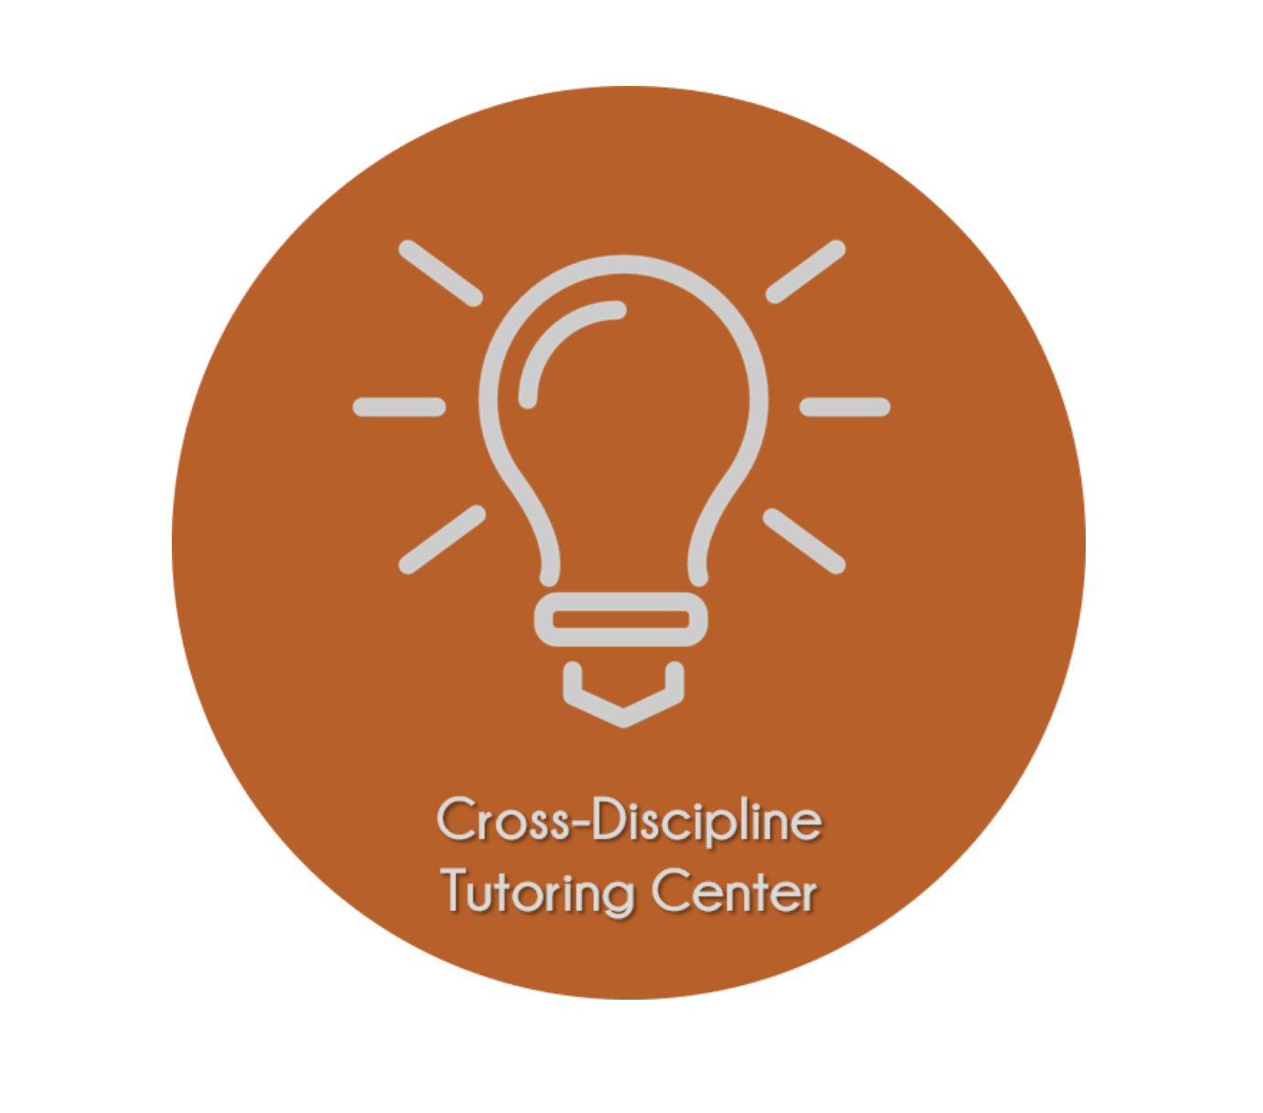

3) If you want a live tutoring session via ConferZoom, then follow the directions for “Drop-in Tutoring”

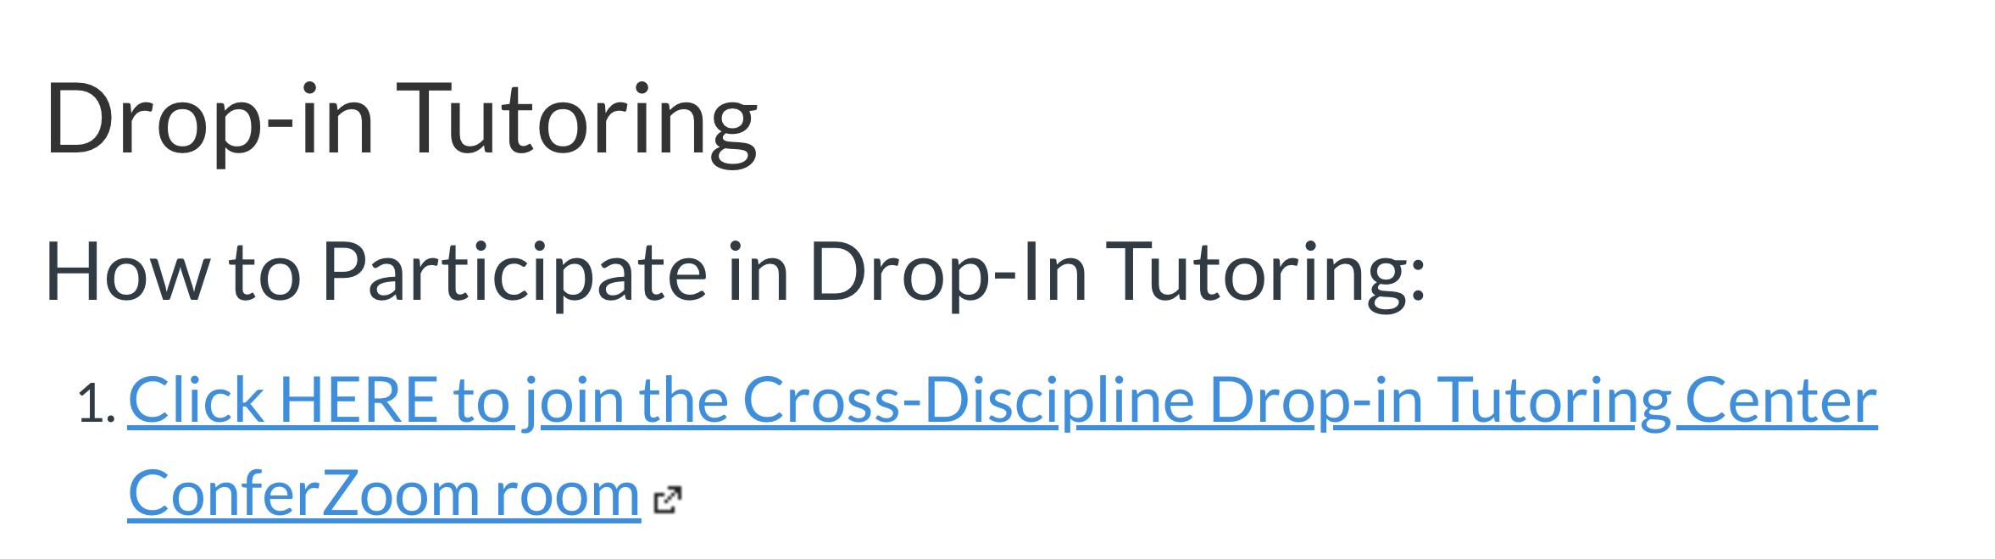

4) If you have a quick question and can wait for a response, then follow the directions for “Discussion Board Tutoring”
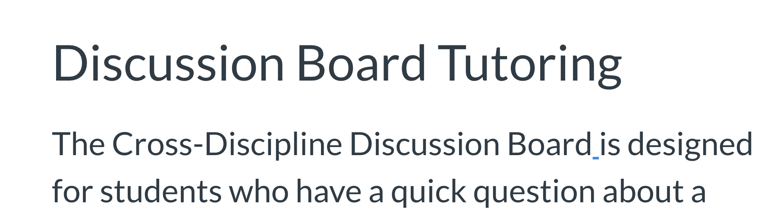

5) If you want to make an appointment for a tutoring session, then follow the directions for “Tutoring Appointments”
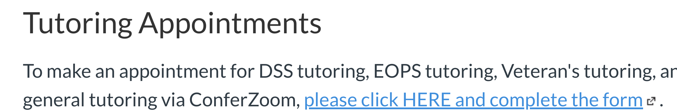

Any questions? Please email Andrew Rempt at arempt@swccd.edu

