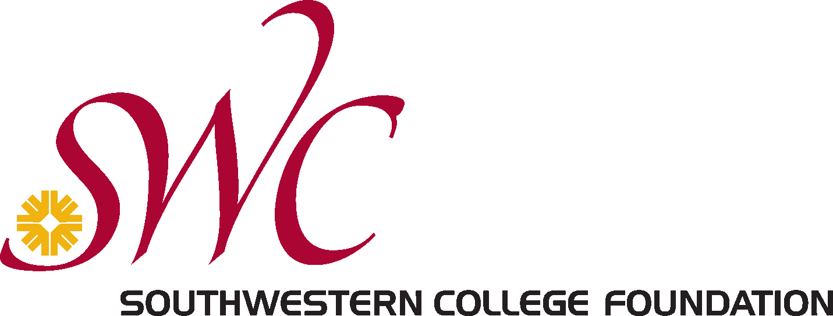

SOUTHWESTERN COLLEGE FOUNDATION
2021-2022 MINI GRANT APPLICATION

COVER PAGE

Name of School/Unit/Department: Click here to enter text.

Name of Project: Click here to enter text.

Amount of Funding Request: Click here to enter text. Date(s) of Project: Click here to enter text.

IMPORTANT NOTE:
Post Project Evaluations must be completed and submitted to SWCF within 30 days after project is concluded. Future funding requests will NOT be considered if the Post Project Evaluation form is not submitted in compliance with this requirement (see next page).

REQUIRED COLLEGE SIGNATURES
Project Director Name: _____________________________________________
Telephone No.: _____________________________ Email: ___________________________________

Signature of Dean, Vice President or Student Club Advisor indicates that the proposed activity is approved and in alignment with the strategic priorities of the college.

_________________________________ _________________________________ __________________
Print Name Signature Date

SWC FOUNDATION APPLICATION REVIEW PROCESS AND DETERMINATION
(for SWCF use only)

Approved: Yes or No Approved Amount: _________________________

Board Approval Date: ___________________ Notification Date: __________________________

Notes: ___________________________________________________________________________________
_________________________________________________________________________________________
_________________________________________________________________________________________
_________________________________________________________________________________________

